SmartStruxure b3 ATB Validation Applications

SmartStruxure Universal Graphic Points

This is a standard point that can be used on the majority of data types on an SmartStruxure graphic.

June 2015 / White Paper

Schneider Electric Buildings BU

Process Excellence and Quality

Application and Engineering Services

Authors: Michael Botens

Standard Applications that allow efficient validation of a Variable Air Volume System

April 2014 / White Paper

Schneider Electric Buildings BU

Customer Service and Quality

Application and Engineering Services

Authors: Michael Botens

Table of Contents

Introduction 3

Component Design 4

Introduction

In an effort to increase the efficiency of displaying SmartStruxure data on a graphic the Engineering Services and Applications team has developed a tgml component that can be used for a wide variety of point types and sources. This point has been tested on BACnet points and SmartStruxure Values values. This component was developed in 1.6 and tested in both 1.6 and 1.7. This component has been tested in both webstation and workstation. The point can display plain text, analog, digital, and multistate data.

This paper describes an overview of the component as well as how to setup the component.

The goal of the component and this paper is to provide a component that will provide a similar experience across most data points.

Component Design

This component is to provide:

* A single component that fits the majority of data display.

Point Types

This component supports the following data types:

* Analog
* Digital
* Multistate
* Plain Text

The data type is changed based on the Value of the Type property on the txtValue object.

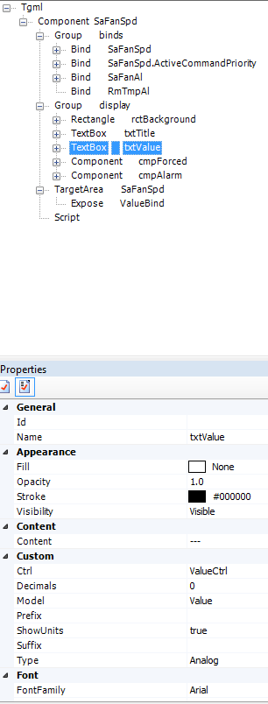

Analog

To enable the analog point data the Type Property should be changed to Analog. This will allow the component to read the following information from the txtValue node.

Decimals – Number of decimal places

Prefix – Text to be displayed before the value

Suffix – Text to be displayed after the value

ShowUnits – Display the SmartStruxure Units associated to the bind.

Digital

To enable the digital point data the Type Property should be changed to Digital. This will allow the component to read the following information from the txtValue node.

State0 – Display Text for when the data is false

State1 – Display Text for when the data is true

Multistate (Multi)

To enable the multistate point data the Type Property should be changed to Multi. This will allow the component to read the following information from the txtValue node.

State# – Display Text for when the state matches the number.

This point type can currently use an unlimited number of states. The states must start at either State0 or State1, but must have continuous states defined up to the highest state. So, even if you don’t have a state 6, if you want a state higher than 6 you should add a state 6 with a value of unused.

Text

This is plain text mode, the component will display the exact text it receives from the bind.

Binds

There are three types of binds associated with this component.

ValueBind – The actual value that needs to be displayed.

ForceBind – BACnet only, this is the bind that indicates whether the data is forced.

AlarmBind – This bind expects a digital value that indicates if the data is in alarm.

ValueBind

This bind should have the data that you would like to display in the box. It also has the force indication for non-BACnet data. It is also used to UnForce data.

ForceBind

This should only be used for BACnet data. This can be either the ActiveCommandPriority, any Priority Level, or OutOfService Attributes. The name of the bind in the graphic tells the component how to use the bind data. **So, be sure to change the name of the bind according to what is bound.**

OutOfService –expects Boolean data

Priority Level (Priority8) – expects a null or non-null value.

ActiveCommandPriority – expects a value between 1 and 16 or null. Values less than 10 are considered forced.

AlarmBind

There can be multiple alarm binds, each bind is expected to be a Boolean value indicating that the data is in or out of alarm. Any true Alarm will result in the component displaying the alarm mode.

Modes

Normal Mode

This is when the data is neither forced nor in alarm.

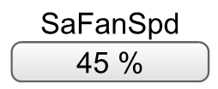

Forced Mode

This is when the data is has been forced. The rectangle behind the hand blinks yellow.

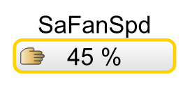

Alarm Mode

This is when the data is in alarm. The rectangle behind the bell blinks red.

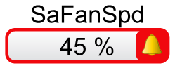

Customizing the Component

You can easily change many of the properties already discussed by editing the properties as stated. You can also customize the colors of the component by changing the different properties of the component.

All display pieces are placed under the display group.

rctBackground

txtTitle

txtValue

cmpForced

cmpAlarm

**Exposed Properties**

ValueBind – name of the bind to be displayed

ForceBind – BACnet Only, name of the force indication bind

AlarmBind – Name of the alarm indication bind

Text Content – The text displayed above the display box

Point Content – Text to be displayed before the value is populated

Prefix – Analog Only, Text to be displayed before the value text

Suffix – Analog Only, Text to be displayed after the value text

Decimals – Analog Only, number of decimals to be displayed on an Analog Value

ShowUnits – Analog Only, Boolean to indicate whether the units of the bind should be displayed

Forced Color – Color of the outline and blinking box when the data is forced

Alarm Color – Color of the outline and blinking box when the data is in alarm